**The Mayo Clinic**

**STAKEHOLDERS**

|  |  |
| --- | --- |
| **ACTOR** | **What he can do on the Software Created** |
| Administrative staff | * Create patient unique ID and enter personal information * Allocate beds and end to end process from admission to discharge * Billing for OPD, IPD lab or radiology services * Maintain cash/ credit scrolls for themselves * Create/access occupancy and Payer reports * Bed allotment and shifting logs * Update discounts and remarks * Mark listing of patients such as VIP or HOT listed |
| Doctors | * Able to mention treatment details and patient condition * Enter medications or tests & lab services that will directly be sent/reflected in concern departments. * Get notified at time of emergency |
| Nurses | * Able to see on-going treatment of patient * Log in vitals and indent medicines as and when needed * Notify Doctors for condition of patient * Maintain their attendance and work logs |
| Senior Management | * He/she can see Total occupancy and generate daily revenue reports * They can access each patient’s location (bed occupied) with doctor details and current treatment (Medical/Surgical) for admitted patients * One can access complete Patient information like name contact no, address etc on single window * Software will enable them to keep a check on daily errors by staff and maintain a log for same * Logs for discounts and remarks will be maintained and accessible * Doctors' appointments and revenue generated through OPDs. * Total number of OPD patients and admitted patients * Which doctors generate the maximum revenue * Total amount of earnings through OPD and admitted patients * Total amount of earnings generated through laboratory and radiology |

**Scope**

The scope of the Hospital Management System (HMS) encompasses a comprehensive set of functionalities designed to streamline and improve the overall management of the Mayo Clinic. Here's an overview of the scope and how it will benefit respective stakeholders:

**1. Patient Registration and Management:**

Scope: The system will allow for efficient registration of new patients, maintaining their medical records and history, and assigning a unique patient ID.

Benefits to Stakeholders:

* + Patients: Convenient and secure access to their medical records, simplified registration process, and seamless tracking of their medical history.
  + Hospital Staff: Improved patient data management, reduced paperwork, and faster access to patient information.

**2. Appointment Management:**

Scope: Patients can schedule appointments with doctors by viewing available time slots on the website. The system will book appointments and send reminders.

Benefits to Stakeholders:

* + Patients: Easy appointment scheduling, reduced waiting times, and appointment reminders for better healthcare planning.
  + Doctors: Efficient appointment management, fewer scheduling conflicts, and improved patient experience.

**3. Bed Occupancy Tracking:**

Scope: The system tracks bed occupancy in real-time, showing available and occupied beds. Updates are made every 6 hours.

Benefits to Stakeholders:

* + Hospital Administrators: Enhanced bed allocation, reduced patient wait times, and improved resource utilization.
  + Nursing Staff: Clear visibility of available beds, enabling quicker patient admissions.

**4. Billing:**

Scope: The system consolidates patient expenses and generates comprehensive bills at the end of consultations or discharge.

Benefits to Stakeholders:

* + Patients: Clear and detailed bills, reduced billing errors, and smoother payment processes.
  + Hospital Finance Department: Streamlined billing procedures and improved financial management.

**5. Laboratory, Blood Bank, and Radiation Department Management:**

Scope: Doctors can prescribe tests and procedures through the system, with results directly uploaded. Patients' test reports are easily accessible.

Benefits to Stakeholders:

* + Doctors: Simplified test prescription, quick access to results, and reduced paperwork.
  + Laboratory/Radiology Staff: Efficient handling of test requests and result reporting.

**6. Reporting:**

Scope: The system generates reports for senior management on revenue, expenses, bed occupancy, and other key metrics.

Benefits to Stakeholders:

* + Senior Management: Data-driven decision-making, improved financial oversight, and enhanced operational efficiency.

**7. Staff Management:**

Scope: The system maintains staff schedules for nurses and ward boys, including their respective ward assignments.

Benefits to Stakeholders:

* + Hospital Administrators: Effective staff management, better allocation of resources, and optimized workflow.

**8. Patient Care Instructions:**

Scope: The system stores doctors' instructions for patient care, ensuring nurses have easy access to treatment plans.

Benefits to Stakeholders:

* + Nursing Staff: Clear treatment guidelines, improved patient care, and reduced errors.

**9. Insurance Details Management:**

Scope: The system stores insurance details for patients with insurance coverage, facilitating claim processing.

Benefits to Stakeholders:

* + Patients with Insurance: Streamlined claims processing and reduced administrative burdens.
  + Hospital Billing and Insurance Teams: Efficient management of insurance-related data.

By implementing this comprehensive scope, the Hospital Management System will contribute to improved patient care, streamlined hospital operations, enhanced data security, and better decision-making for all stakeholders involved in the Mayo Clinic.

**WORKFLOW OF THE PROPOSED SYSTEM**

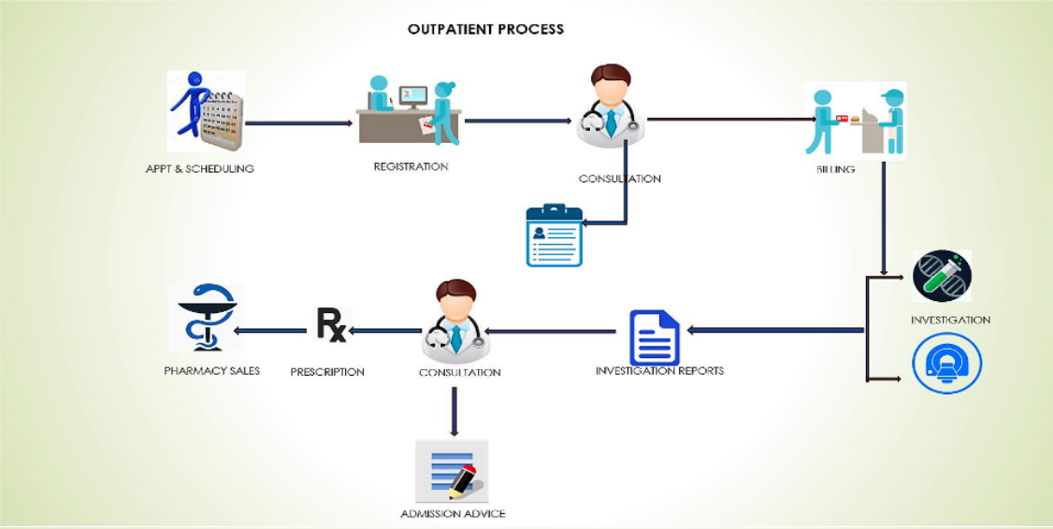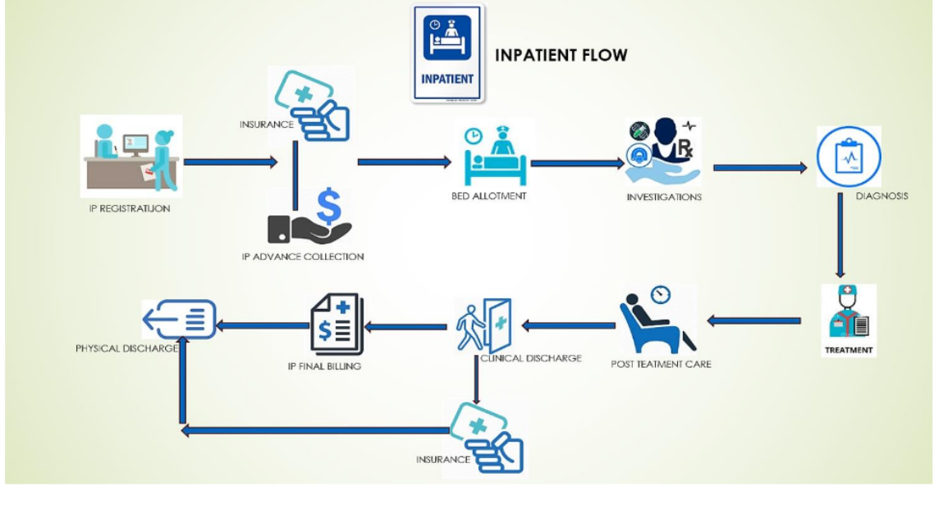

**SCOPE using Use Case Diagram (UML)**

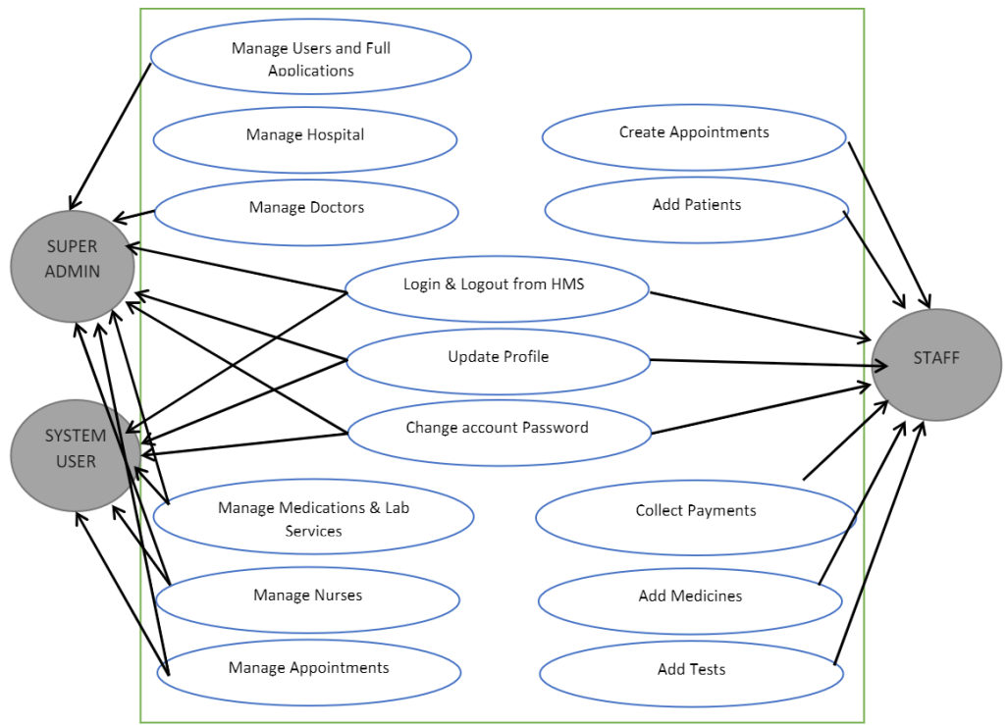

**IN SCOPE**

* OPD Billing Module where in patient registration, details will be fed along with billing for lab and pathological test, Doctor Consultation and other procedures.
* Any modifications to be done pertaining to patient details can be done in OPD module along with details of invoices and revenue, discount and other Reports will be updated here
* OPD scroll for Hospital Staff will also be available in OPD Module.
* IPD module will be subdivided into Emergency Module as well where in Bed allotment IP billing and patient admission process will be done.
* Another sub division in IP module will be for Insurance where in TPA Patient details will be reflected and processing for them would be done
* A separate module for nursing doctors and lab will be there where in each Nurse will be able to see Line of treatment for patient, enter vitals log and see medications for patients.
* Nurses can intimate doctors in case of emergency and access lab reports as well
* Doctors will be able to enter patient treatment details and diagnosis and see test reports, create discharge summaries, prescriptions.
* Doctors can modify and update their schedules of appointments which will directly be notified to patients
* Lab staff can enter reports and receive notifications whenever an investigation is suggested in case of IP
* Pharmacy module will maintain logs for stocks and provide medications to IP as well as OP Patients as when required and generate daily reports for same

**OUT OF SCOPE**

* HMS at this stage wont be able to allow chats or video consult with Doctors
* It wont notify for upcoming events or tasks
* Educate Staff
* Generate risk reports

**ER Diagram for HMS**

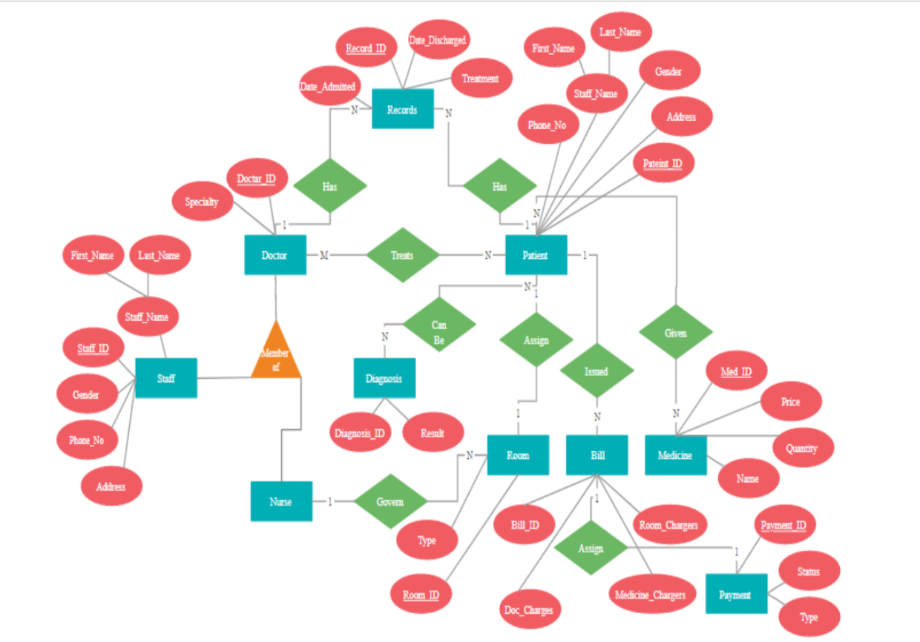

**Data Flow Diagram for HMS**

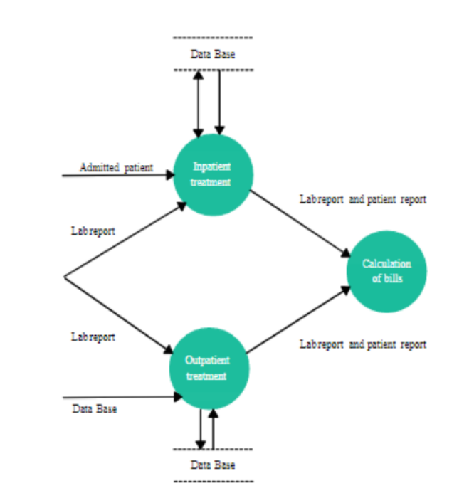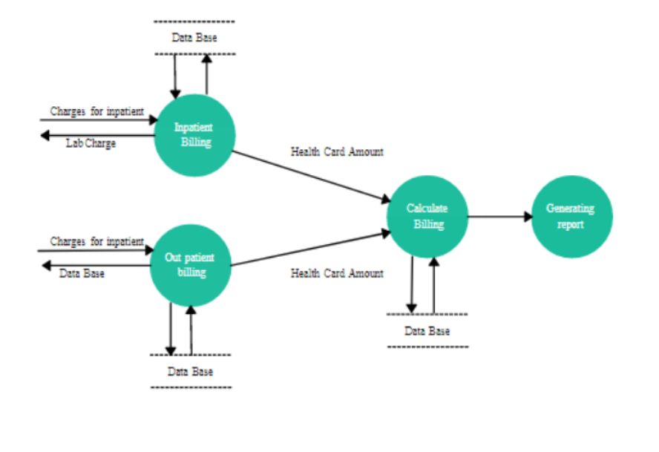

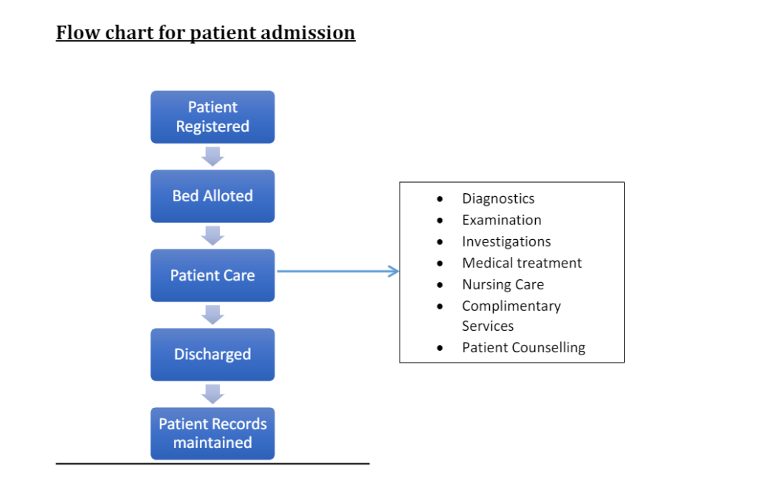

**FUNCTIONAL REQUIREMENTS**

There are a lot of software requirements specifications included in the functional requirements of the Hospital Management System, which contains various process, namely Registration, Check out, Report Generation, and Database.

Registration Process of SRS (Software Requirements Specification)

* Adding Patients: The Hospital Management enables the staff in the front desk to include new patients to the system.
* Assigning an ID to the patients: The HMS enables the staff in the front desk to provide a unique ID for each patient and then add them to the record sheet of the patient. The patients can utilize the ID throughout their hospital stay.

Check Out of SRS:

* Deleting Patient ID: The staff in the administration section of the ward can delete the patient ID from the system when the patient's checkout from the hospital.
* Adding to beds available list: The Staff in the administration section of the ward can put the bed empty in the list of beds-available.

Report Generation of SRS:

* Information of the Patient: The Hospital Management System generates a report on every patient regarding various information like patients name, Phone number, bed number, the doctor's name whom its assigns, ward name, and more.
* Availability of the Bed: The Hospital Management system also helps in generating reports on the availability of the bed regarding the information like bed number unoccupied or occupied, ward name, and more.

Database of SRS:

* Mandatory Patient Information: Every patient has some necessary data like phone number, their first and last name, personal health number, postal code, country, address, city, 'patient's ID number, etc.
* Updating information of the Patient: The hospital management system enables users to update the information of the patient as described in the mandatory information included.

**NON-FUNCTIONAL REQUIREMENTS**: There are a lot of software requirements specifications included in the non-functional requirements of the Hospital Management System, which contains various process, namely Security, Performance, Maintainability, and Reliability.

**Security:**

* Patient Identification: The system needs the patient to recognize herself or himself using the phone.
* Logon ID: Any users who make use of the system need to hold a Logon ID and password.
* Modifications: Any modifications like insert, delete, update, etc. for the database can be synchronized quickly and executed only by the ward administrator.

Front Desk Staff Rights:

The staff in the front desk can view any data in the Hospital Management system, add new patients record to the HMS but they don't have any rights alter any data in it.

Administrator rights:

* The administrator can view as well as alter any information in the Hospital Management System.

Performance:

* Response Time: The system provides acknowledgment in just one second once the 'patient's information is checked.
* Capacity: The system needs to support at least 500 people at once.
* User-Interface: The user interface acknowledges within five seconds.
* Conformity: The system needs to ensure that the guidelines of the Microsoft accessibilities are followed.

Maintainability:

* Back-Up: The system offers the efficiency for data back up.
* Errors: The system will track every mistake as well as keep a log of it.

Reliability:

* Availability: The system is available all the time.

**System Requirement:**

**Usability:**

* Database: MySQL Database to be used since it is open source and free.
* Operating System: Shall be Windows 2016
* Web-Based: The system shall be a web-based application
* Response Time: The system shall give responses in 1 second
* Capacity: The System must support 500 people using it at a time
* Errors: The system shall keep a log of all the errors
* Availability: The system shall be available all the time
* Usability: The screens should be self-explanatory and very user friendly. Management would not want employees not ordering from the system as they cannot understand the screens and data fields on screen. The users should not find the system cumbersome.

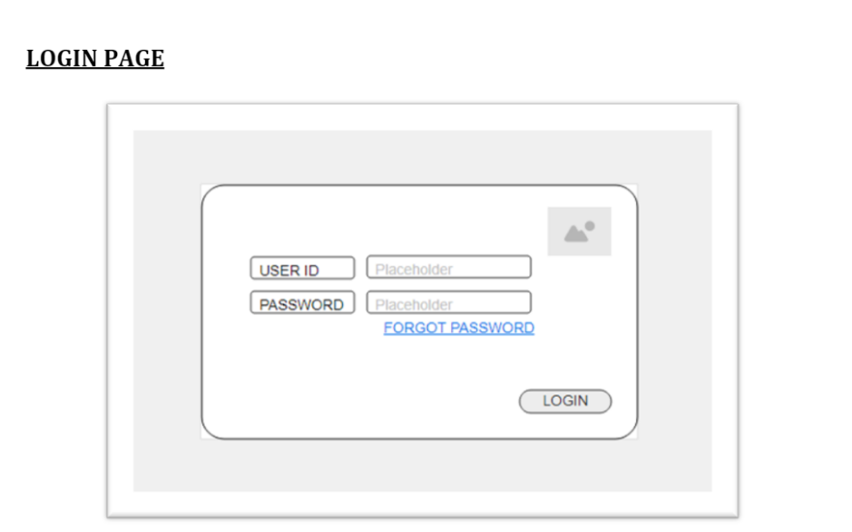

The Login Page will have Mayo Clinic's Logo on top right Corner with User ID where user will fill in their employee ID to Login to HMS and passwords as provided to them.

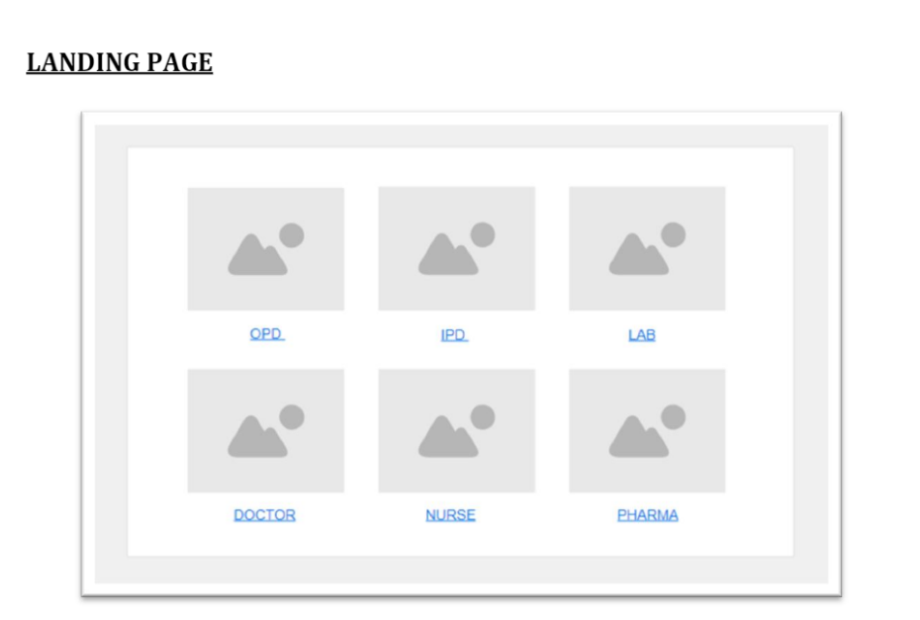

Post login user will be able to see this page where in He/She will have to select which module they have to work in.

* If accessing OPD Admin Staff will further be taken to OP registration , billing page .
* If accesing IPD Admin Staff will further be taken to IP Module where in they will be able to do admission registration, a lot beds, Select Payor(TPA), billing for admitted patients including Emergency
* In LAB testing services and reports for Radiology and Pathology will be available
* Doctors can enter treatment details and indent tests and other services
* Nurses will be able to perform there tasks in Nursing module
* Pharma related billing , medicine stocks will be taken care of this module